Text A

____________ of Scone, also called _________ of Destiny, for centuries was associated with the crowning of Scottish kings and then, in 1296, was taken to England and later placed under the Coronation Chair. The _________, weighing 336 pounds (152 kg), is a rectangular block of pale yellow sand _________ (almost certainly of Scottish origin) measuring 26 inches (66 cm) by 16 inches (41 cm) by 11 inches (28 cm). A Latin cross is its only decoration.
According to one Celtic legend, the ________ was once the pillow upon which the patriarch Jacob rested at Bethel when he beheld the visions of angels. From the Holy Land it purportedly traveled to Egypt, Sicily, and Spain and reached Ireland about 700 BCE to be set upon the hill of Tara, where the ancient kings of Ireland were crowned. Thence it was taken by the Celtic Scots who invaded and occupied Scotland. About 840 CE it was taken by Kenneth MacAlpin to the village of Scone.
At Scone, historically, the ________ came to be encased in the seat of a royal coronation chair. John de Balliol was the last Scottish king crowned on it, in 1292, before Edward I of England invaded Scotland in 1296 and moved the ________ (and other Scottish regalia) to London. There, at Westminster Abbey in 1307, he had a special throne, called the Coronation Chair, built so that the __________ fitted under it. This was to be a symbol that kings of England would be crowned as kings of Scotland also.
Attached to the __________ in ancient times was allegedly a piece of metal with a prophecy that Sir Walter Scott translated as
Unless the fates be faulty grown
And prophet’s voice be vain
Where’er is found this sacred _________
The Scottish race shall reign.
When Queen Elizabeth I died without issue in 1603, she was succeeded by King James VI of Scotland, who became James I of England (or Great Britain). James was crowned on the ________ of Scone, and patriotic Scots said that the legend had been fulfilled, for a Scotsman then ruled where the ________ of Scone was.
On Christmas morning 1950 the ________ was stolen from Westminster Abbey by Scottish nationalists who took it back to Scotland. Four months later it was recovered and restored to the abbey. In 1996 the British government returned the ________ to Scotland.

What object is described above? Complete the gaps with ONE word. _____________ (5p)
What’s the Scottish Gaelic name for this object? ______________ (2p)
Where is it now? __________________ (3p)

Text B
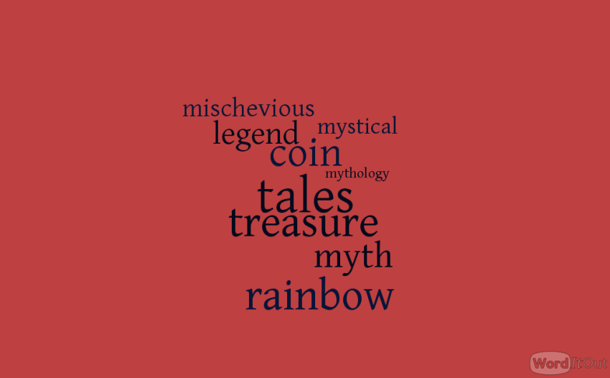

__________ of the Leprechaun
The _______________ of the Leprechaun is one of the most enduring ________________s in Ireland and relates to a ____________ type of fairy who is originally linked to the Tuatha De Danann of Irish ________________.
According to fables, Leprechauns are tiny entities that normally take the form of an old man in a red or green coat. They are known to be ___________________ little creatures that like to make shoes and store their gold ___________s in a pot of gold that is hidden at the end of a__________________. If you happen to capture a Leprechaun, he will give you three wishes provided you let him go.

Leprechaun Origin
Most Leprechaun ________________s can be traced back to the 8th century tales of water spirits which were known as ‘luchorpán’ which means ‘small body’. It is said that these spirits merged with a household fairy and developed a penchant for heavy drinking so no cellar was safe! According to other researchers, the term Leprechaun actually comes from the Irish term ‘leath brogan’ which means shoemaker.
It is interesting to note that Leprechauns are often associated with wealth, particularly gold _____________, but they are actually cobblers which you would hardly presume is a lucrative vocation! Nonetheless, the myth of the pot of gold persists and there are still people who go looking for this hidden ________________!

The Pot of Gold
This is the most common of all Leprechaun __________________s which says that they find gold _____________s buried in the earth and store them all in a pot which is hidden at the end of a ___________________. The fact that a ________________doesn’t have a fixed spot or a real end should be discounted for the sake of the story!
Quite why Leprechauns even need gold is another matter entirely since they can’t actually spend it. Some researchers suggest that this gold is used as a means of tricking humans and given the Leprechauns’ propensity for trickery, this is entirely possible.
In most Irish folklore ____________ featuring the Leprechaun, he is depicted as a rogue who will deceive whenever he can. In rare cases where humans catch Leprechauns in __________, they are easily outsmarted by the magical creature that often uses a person’s greed against him. Unless you are an expert in all things Leprechaun, there are a few facts about the _____________ trickster that may surprise you.

The modern day depiction of a Leprechaun is that of a man clad entirely in green. However, Irish folklore describes Leprechauns as men who wore red outfits and tri-cornered hats. Irish novelist Samuel Lover describes Leprechauns as such in his 1831 work ____________s and Stories of Ireland.
According to Carolyn White’s A History of Irish Fairies, there is no record of any female Leprechauns existing. This of course means that Leprechauns defy typical laws of biology by surviving and there is no evidence which tells the story of how they breed. The aforementioned book says that Leprechauns are actually deformed children of the fairies.

1) What will a Leprechaun do for you if you let him go? __________________________ (5p)
2) According to the text where does the word Leprechaun come from?
a) ______________________________ (1p)
b) ______________________________ (1p)
3) What is the object of the Leprechaun hunt? __________________________________ (3p)

